Q1 | Create a table called Playlist with columns: id (INT, primary key), song_name (VARCHAR), artist (VARCHAR), and duration (INT, seconds). Insert a single row for your current favorite song.
Code | CREATE TABLE playlist(  id INT PRIMARY KEY,  song_name varchar(100),  artist varchar(100),  duration INT  );  INSERT INTO playlist (id, song_name, artist, duration)  VALUES  (1, 'cry for you', 'The Weeknd', 406);
Output | 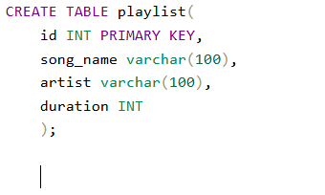  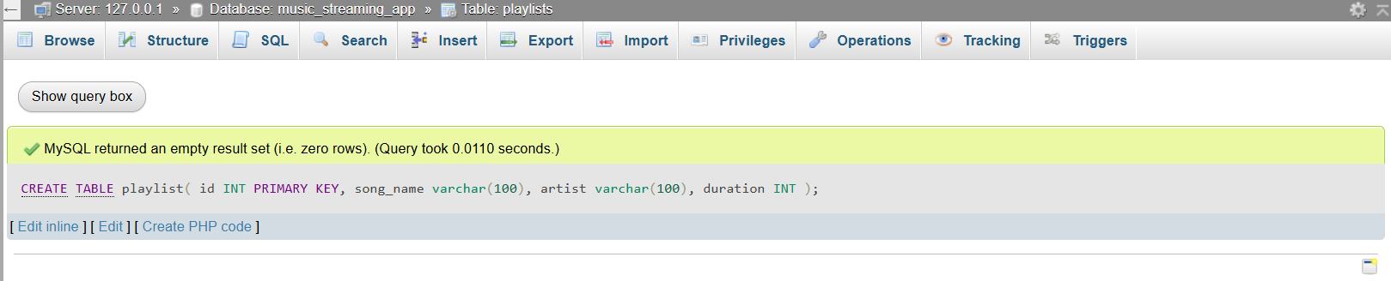    

Q2 | Insert 3 new rows into the Playlist table for songs you recently listened to on Spotify, including their song_name, artist, and duration.
Code | INSERT INTO Playlist (id, song_name, artist, duration) VALUES  (2, 'Finding Her', 'Kushagra and Saaheal', 327),  (3, 'samjho na', 'Aditya Rikhari', 252),  (4, 'Bargad', 'Toorjo Dey', 255);
OUtput | 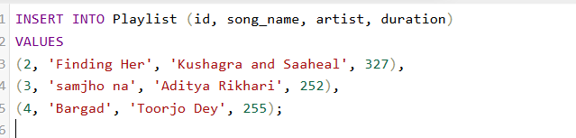  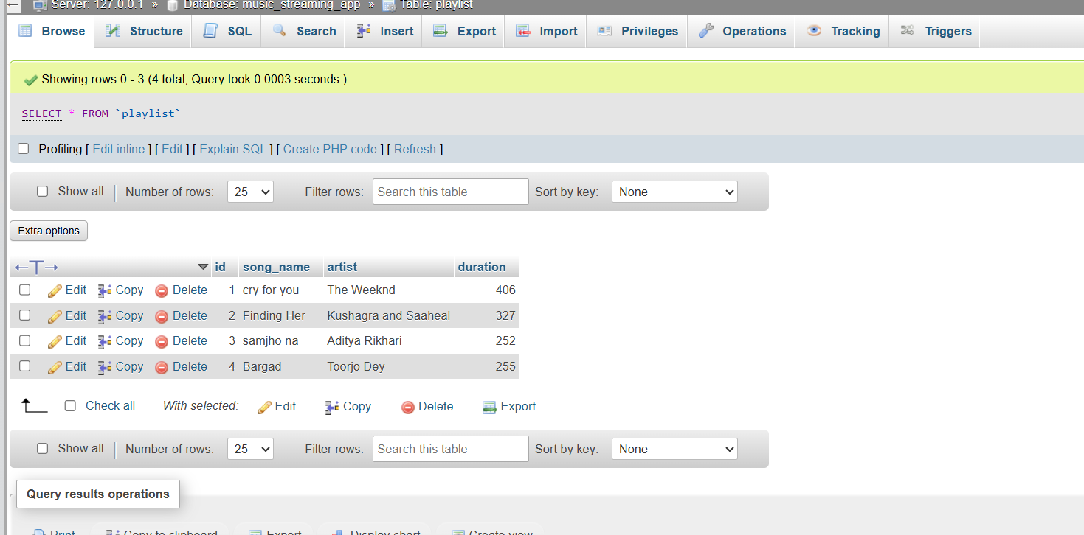

Q3 | Update the artist name for one of your Playlist entries to fix a typo (for example, change 'Arjit Singh' to 'Arijit Singh') using the UPDATE statement with a WHERE clause.
Code | UPDATE playlist SET artist = 'Aditya Rikh' WHERE artist = 'Aditya Rikhari';
Output | 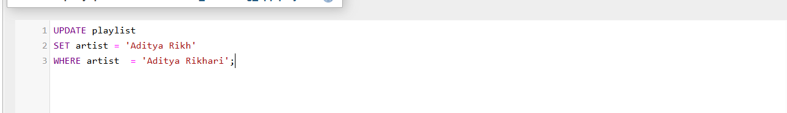    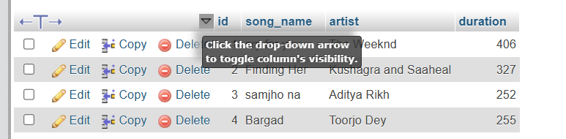

Q4 | Delete a song from the Playlist table where the duration is less than 120 seconds using the DELETE statement and a WHERE clause.<br><br><em><strong>Hint:</strong> Make sure your WHERE clause is specific so you don’t accidentally delete all rows.</em>
Code | DELETE FROM playlist  WHERE duration < 120;
Output | 

Q5 | Write an SQL statement that would update the song_name for all songs by 'AP Dhillon' in your Playlist to add '(Remix)' at the end of the name, but only if the duration is more than 180 seconds.<br><br><em><strong>Constraint:</strong> Combine UPDATE with WHERE to target only the correct rows.</em>
Code | UPDATE Playlist  SET song_name = CONCAT(song_name, ' (Remix)')  WHERE artist = 'The Weeknd'  AND duration > 180;
Output | 